1.

You have a DNS server named DNS1 that hosts several forward lookup zones.

You discover that dynamic records exist for computers that were removed from your network several months ago.

You need to ensure that the records are removed automatically.

Which two actions should you perform? Each correct answer presents part of the solution

NOTE: Each correct selection is worth one point.

1. For each zone, set Dynamic updates to **Secure only**
2. From the Advanced settings of the DNS server properties, select **Enable automatic scavenging of stale records.**
3. From the Start of Authority (SOA) settings of each zone, configure the Refresh interval setting and the Expires after setting.
4. From the Start of Authority (SOA) settings of each zone, configure the Retry interval setting and the Minimum (default) TTL setting,
5. For each zone, select **Scavenge stale resource records.**

Answer: B, E

2.

Your network contains an Active Directory domain named contoso.com. The domain contains a DNS server named Server 1. Server is configured as shown in the following exhibit

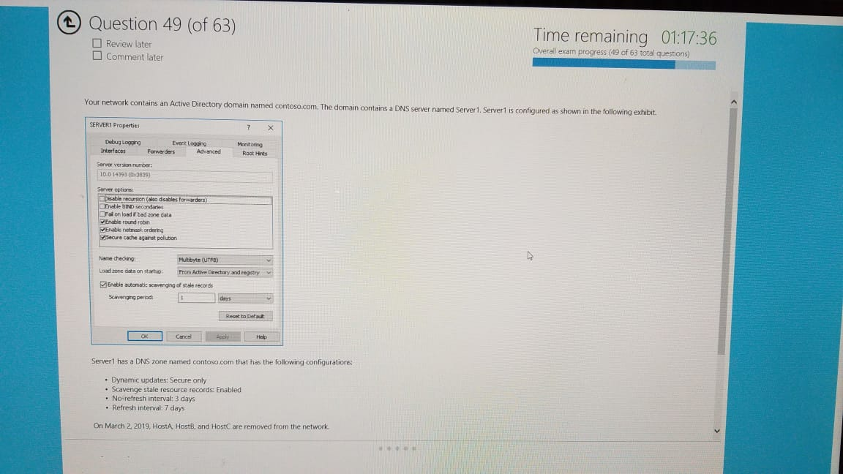

Server1 has a DNS zone named contos.com that has the following contigurations

* Dynamic updates: Secure only
* Scavenge stale resource records Enabled
* No-refresh interval: 3 days
* Refresh interval: 7 days

On March 2, 2019, Hosta Hostel, and Host are removed from the network

The contosa.com zone includes the records shown in the following table

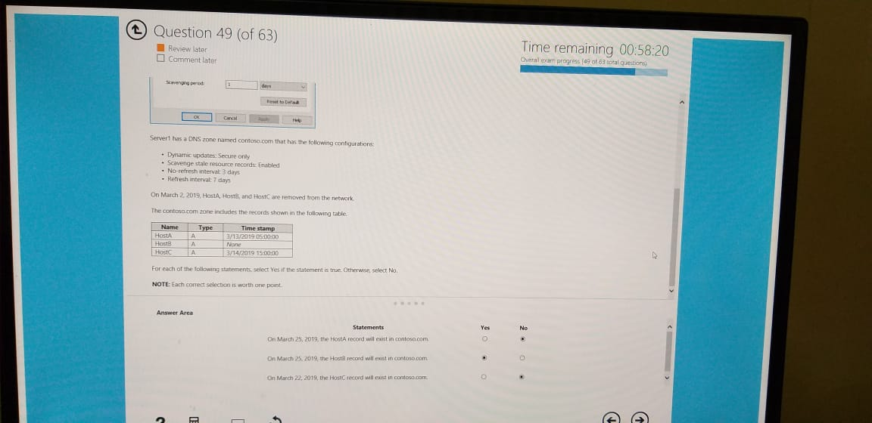

For each of the following statements select Yes if the statement is true. Otherwise select No.

NOTE: Each correct selection is worth one point

Answer Area:

|  |  |  |
| --- | --- | --- |
| Statements | Yes | No |
| On March 25, 2019, the HostA record will exist in contoso.com |  |  |
| On March 25, 2019, the HostB record will exist in contoso.com |  |  |
| On March 25, 2019, the HostC record will exist in contoso.com |  |  |

Answer: No, Yes, No

3.

You have a Remote Access infrastructure.

You plan to implement DirectAccess.

Which type of certificate should you install on each DirectAccess servet2. To answer, select the appropriate options in the answer area

NOTE: Each correct selection is worth one point.

Answer Area:

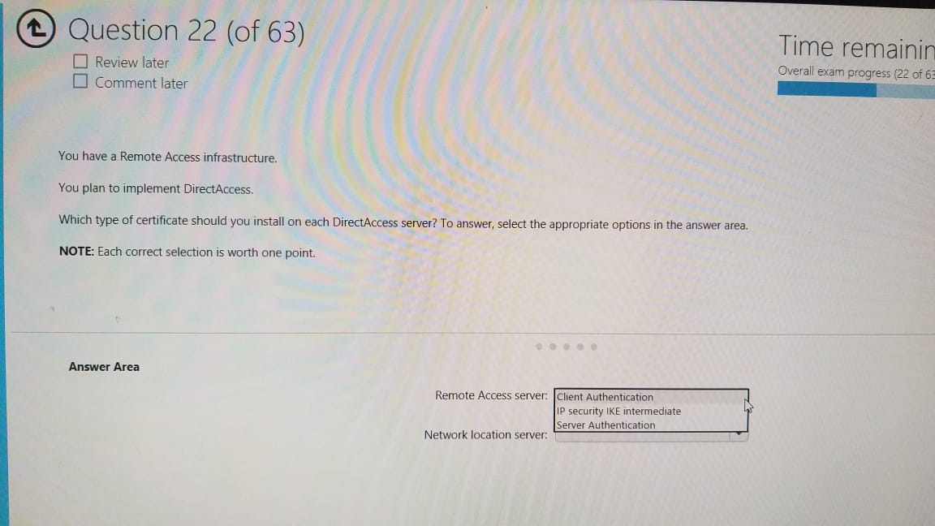Remote Access server:

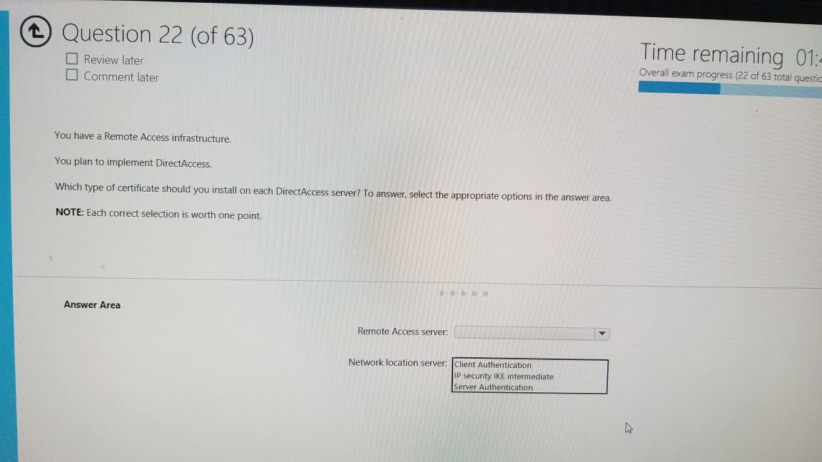Network location server:

Answer: 3, 2

4.

You have a Hyper-V host named Server that runs the virtual machines shown in the following table

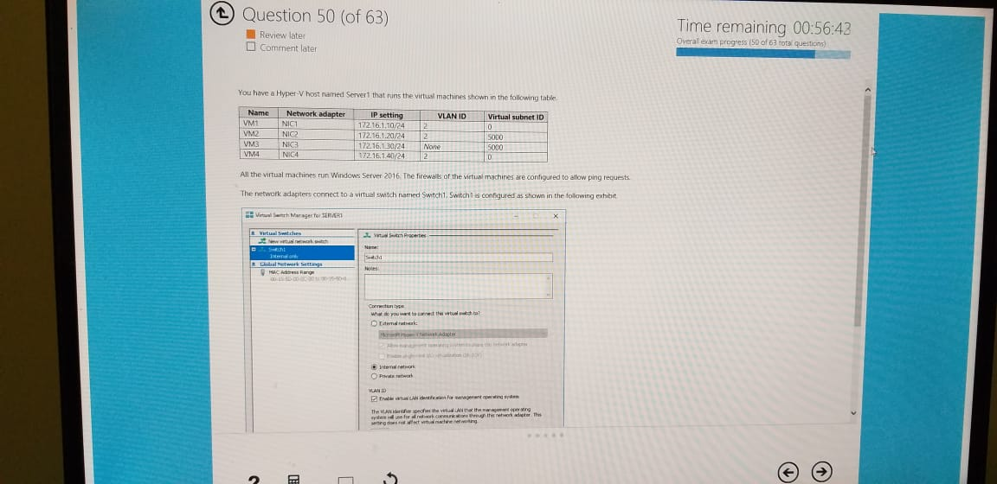

All the virtual machines run Windows Server 2016. The firewall of the virtual machines are configured to allow ping requests.

The network adapters connect to a virtual swich named Switch, Switch is configured as shown in the following exhibit

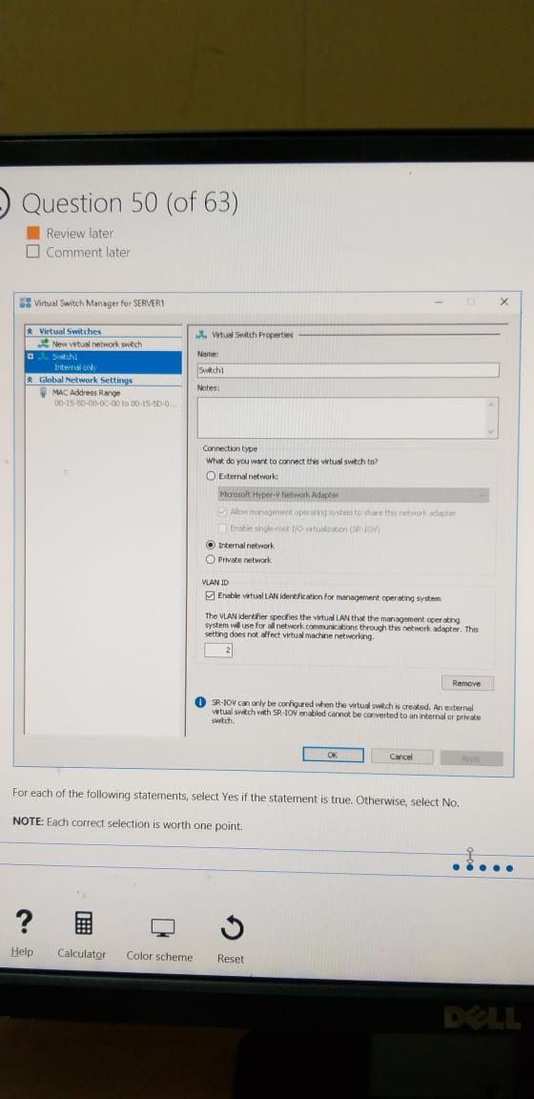

For each of the following statements, select Yes if the statement is true. Otherwise, select No.

NOTE: Each correct selection is worth one point.

Answer Area:

|  |  |  |
| --- | --- | --- |
| Statements | Yes | No |
| From VM1, you can ping VM2 successfully |  |  |
| From VM1, you can ping VM3 successfully |  |  |
| From VM1, you can ping VM4 successfully |  |  |

Answer: No, No, Yes

5.

You have servers that run Windows Server 2016 and devices that run Windows 10 Enterprise.

You have a certification authority (CA) that issued computer certificates to all the servers and devices.

You plan to allow the Windows 10 devices to connect to the network remotely by using VPN device tunnels.

You install the Remote Access server role on a server. From the Routing and Remote Access console, you configure the server for the VPN role.

You need to ensure that the Windows 10 devices can establish the VPN tunnel before users sign into the devices.

What should you do on the VPN server?

1. Modify the ports properties and add additional IKEV2 ports,
2. Modify the ports properties and add additional SSTP ports.
3. From Authentication Methods, select **Extensible authentication protocol (EAP).**
4. From Authentication Methods, select **Allow machine certificate authentication for IKEV2.**

Answer: C

6.

You plan to deploy a Software Defined Networking (SDN) infrastructure.

Which service provides name resolution for the virtual machines on a tenant network?

1. a smart host
2. iSNS
3. Network Controller
4. iDNS

Answer: D

7.

You have a server named Server1 that runs Windows Server 2016 and is configured as a domain controller.

You install the DNS Server role on Server 1.

You plan to store a DNS zone in a custom Active Directory partition

You need to create a new Active Directory partition for the zone.

What should you use?

1. Set-Dns Server
2. Ntdsutil.exe
3. Active Directory Administrative Centre
4. Dns.exe

Answer: B

8.

You have an Active Directory forest that contains 30 servers and 6,000 client computers.

You deploy a new DHCP server that runs Windows Server 2016.

You need to retrieve the list of the authorized DHCP servers.

Which command should you run?

1. Netsh DHCP show server
2. Netsh DHCP server initiate auth
3. Get-DHCPServerSetting
4. Netstat -p IP-s -a

Answer: A

9.

Your network contains an Active Directory domain. The domain contains a server named Server1.

You need to configure Server 1 as a DHCP relay agent.

What should you do? To answer, select the appropriate options in the answer area.

NOTE: Each correct selection is worth one point.

Answer Area:

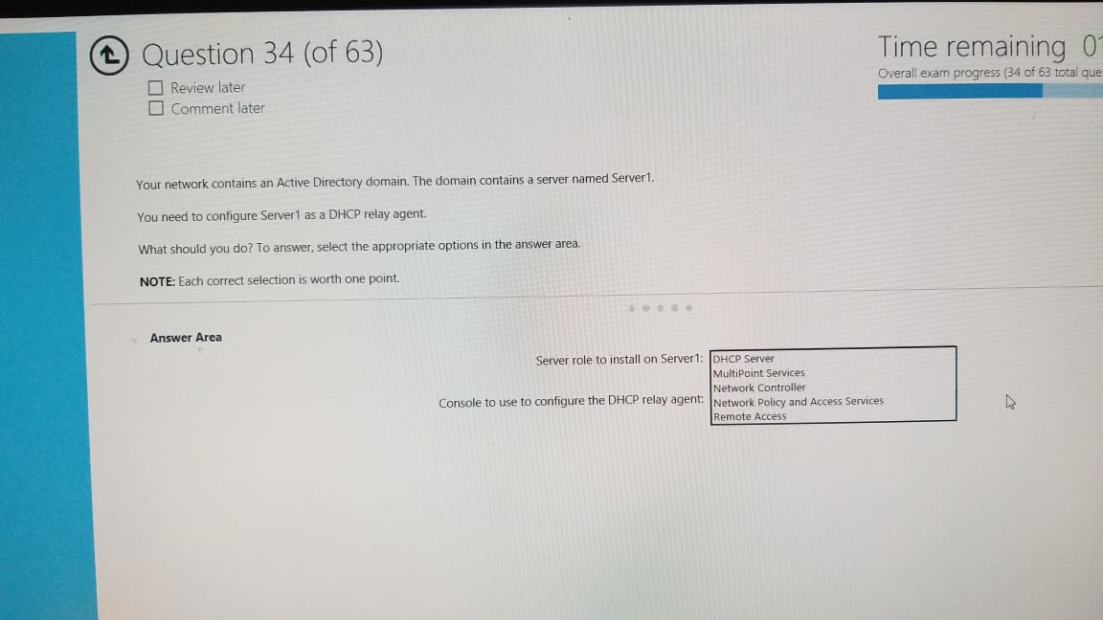

Server role to install on Server1:

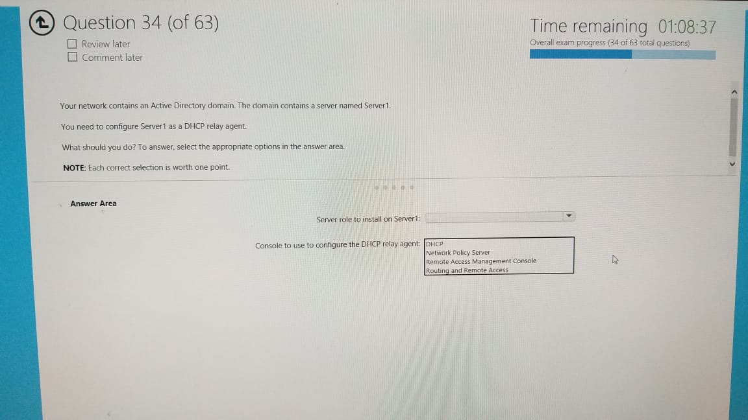Console to use to configure the DHCP relay agent:

Answer: 1, 3

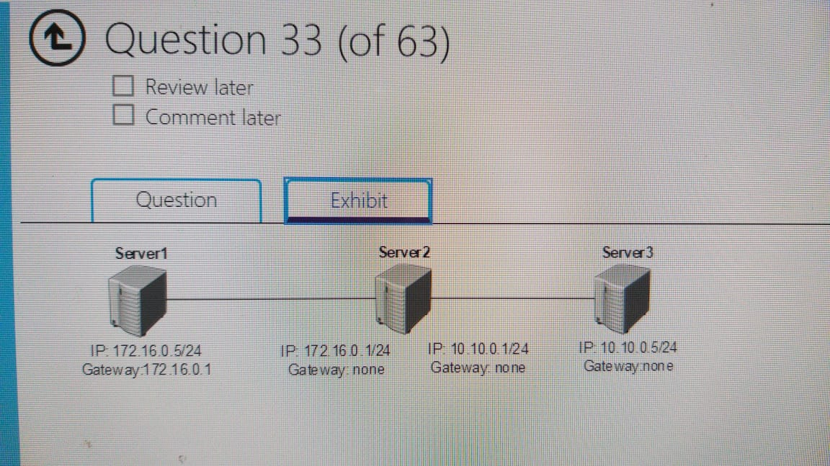10.

You have three servers that run Windows Server 2016. The servers are connected as shown in the exhibit. (Click the Exhibit tab.)

On all the servers, Windows Firewall is configured to allow ping traffic.

You start Routing and Remote Access Service (RRAS) on Server 2.

You need to identify which IP addresses you can ping successfully from Server 1 and Server 3.

What should you identify? To answer, select the appropriate options in the answer area.

NOTE: Each correct selection is worth one point.

**Answer Area:**

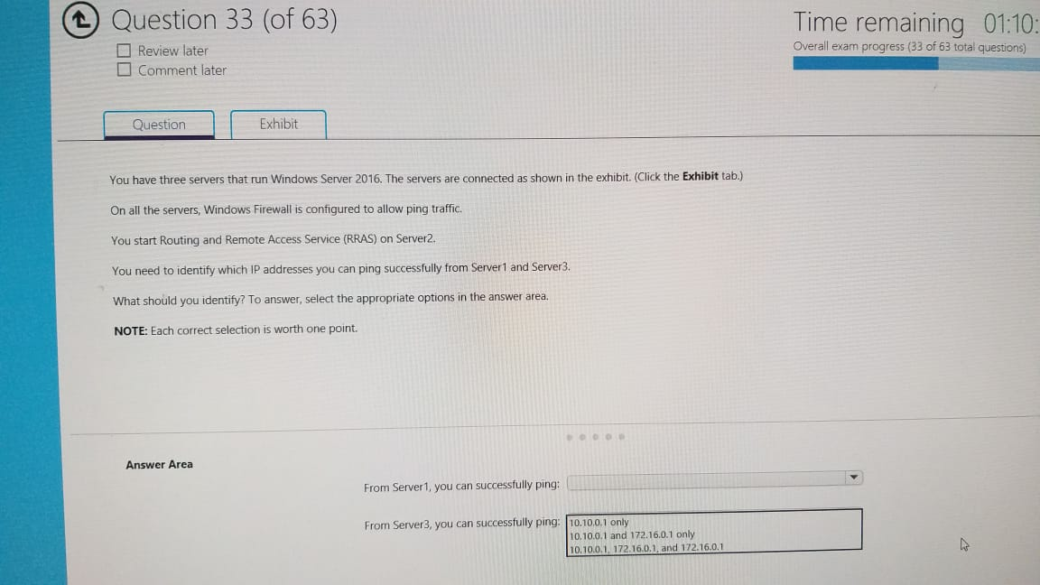From Server1, you can successfully ping:

From Server3, you can successfully ping:

Answer: 1, 2